# Room Layouts

## Room 1: Introductions and Orientation

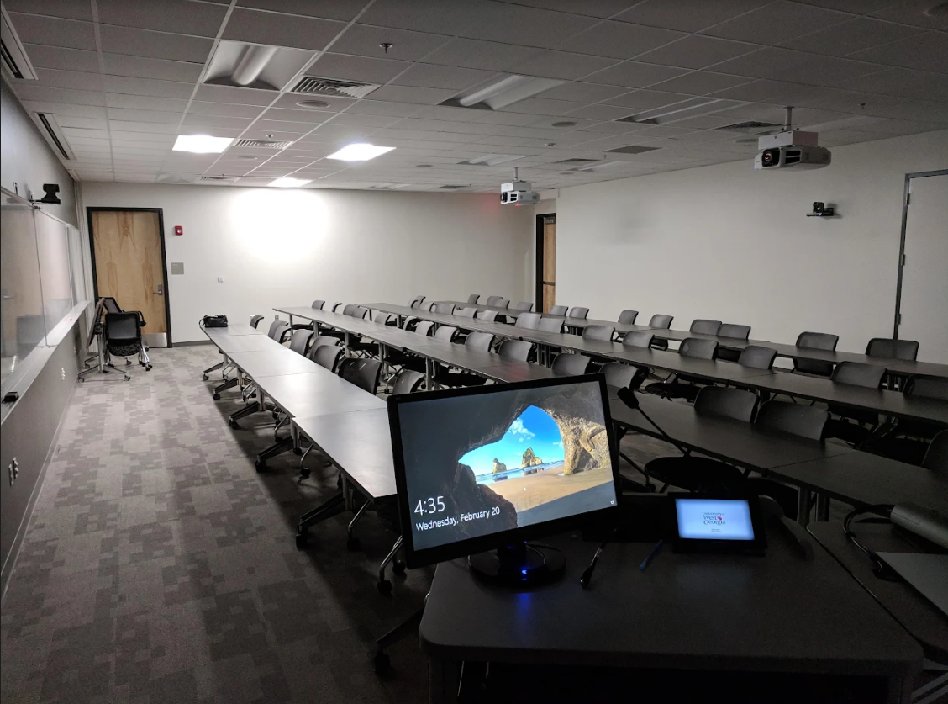

## Room 2: Working in Collaborative Teams: Version 1

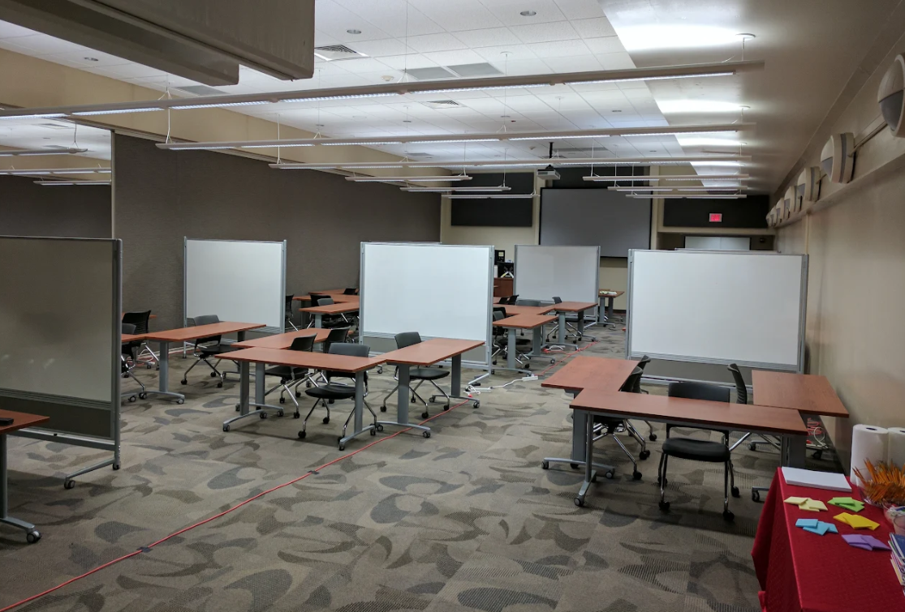

Room 2: Working in Collaborative Teams: Version 2

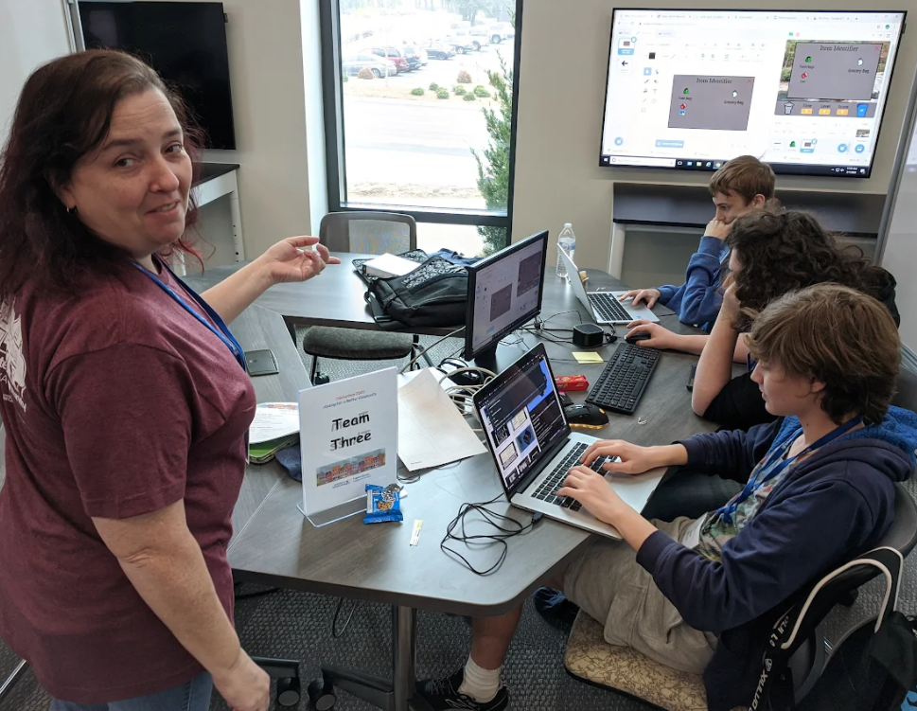

## Room 3: Presenting, Listening, and Awards

